CJFAS Article
Dan and John: please pick a, b, or edit further. I prefer a.
Thanks, Russ

a.) Network-scale thermal and habitat heterogeneity structure phenotypic diversity in a Chinook salmon spawning portfolio

Russell F. Thurow^{1†*} (ORCID iD: 0000-0002-1362-8599)
Bryan M. Maitland^{2†} (ORCID iD: 0000-0002-4491-5064)
Morgan M. Sparks² (ORCID iD: 0000-0003-0787-2218)
Daniel J. Isaak² (ORCID iD: 0000-0003-2963-1546)
John M. Buffington² (ORCID iD: 0000-0002-2513-5863)

¹US Forest Service, Rocky Mountain Research Station (Emeritus), Salmon, ID, USA 83467
²US Forest Service- Rocky Mountain Research Station, Boise, Idaho, USA 83702.
† Dual first authors
*Corresponding author (e-mail: russ.thurow@usda.gov)
Abstract
Pacific salmon exhibit diverse life histories and local adaptation shaped by spatiotemporal variation in biotic and abiotic conditions. This biocomplexity buffers populations against environmental variability and reduces risks of demographic failure. One key aspect of biocomplexity is spawning phenology, i.e., the timing associated with gonadal maturation and egg deposition. Previous studies on salmonid spawning phenology are often constrained to a small number of sites, which limits our understanding of the importance of spatial diversity in promoting biocomplexity and resilience. To this end, we observed when 3,016 wild Chinook salmon (Oncorhynchus tshawytscha) redds were completed from 2002-2005 across diverse habitat conditions in a wilderness river network and evaluated how stream- and reach-scale thermal conditions and spatial habitat variation influenced spawn timing. Linear mixed-effects models with stream-reach random intercepts and slopes explained most of the variation in observed salmon spawning dates (marginal R² = 0.599; conditional R² = 0.990). Spawn timing occurred earlier in sites with cooler antecedent 90-day mean water temperature but plateaued at the warmest sites in downstream areas. Stream and year effects were also significant, with spawning occurring progressively later across years due to a short-term warming trend in our dataset. Importantly, reach-specific random slopes revealed heterogeneity in thermal sensitivity, suggesting that unmeasured local hydrologic and geomorphic processes mediate phenological responses to temperature. Together, these results demonstrate that fine-scale habitat and thermal heterogeneity expressed throughout a network structure phenological diversity in these salmon populations. Notably, this diversity persists despite the low contemporary abundances of these populations and may be critical for maintaining the adaptive capacity of Chinook salmon to dynamic and changing future environments.
Keywords
Spawn timing, portfolio effect, biocomplexity, life history diversity, phenotypic plasticity, habitat heterogeneity, resilience
Introduction
Pacific Salmon populations exhibit extraordinary life history diversity, shaped by complex and heterogeneous environments across their range (Brannon et al. 2004). The enormous diversity of salmon life history traits (Waples et al. 2004) evolved in response to spatiotemporal variation in both biotic and abiotic conditions (Stearns 1976) and acts to reduce risks of demographic failure by buffering populations against environmental change and exploitation (Hilborn et al. 2003, Greene et al. 2009; Schindler et al. 2010; Beamish 2016). Chinook salmon (Oncorhynchus tshawytscha) display an especially diverse demographic portfolio characterized by a broad array of phenotypes, including variation in age and timing of seaward migration, duration of freshwater and marine residence, ocean distribution, age and season of spawning migration, and timing of spawning (Healey 1991).
Among these traits, the timing of adult migrations and subsequent spawning play important roles in shaping reproductive isolation among temporally segregated groups and contribute to fine-scale local adaptation (Quinn et al. 2001; Manhard et al. 2017).
While migration and run timing (entry into freshwater) are often used to define subspecific groupings (e.g., spring, summer, or fall-run fish; Brannon et al. 2004; Waples et al. 2004), spawn timing (the date adults deposit fertilized eggs in gravel) is a comparably important phenological event at the end of salmon life cycles. And despite occurrence within the same run-time grouping, s
pawn timing often varies significantly among local salmon populations in response to both genetic components (Ricker 1972; Quinn et al. 2002; Beulke et al. 2023) and local habitat conditions (Kaylor et al. 2022). Temperature, in particular, strongly influences salmonid spawn timing (Henderson 1963; Morrison and Smith 1986; Beechie et al. 2008) because embryonic development rates are mechanistically driven (Beacham and Murray 1990) and salmon spawn at times that ultimately synchronize fry emergence with conditions to optimize offspring growth and development (Quinn 2018; though see Sparks et al. 2019). As a result, many studies have linked thermal regimes to observed variation in spawn timing (Sheridan 1962; Burger et al. 1985; Heggberget 1988; Lisi et al. 2013). The majority of previous work has occurred within laboratory settings or at small scales in the field rather than the broader areas and diverse thermal conditions that would be useful to characterize phenological portfolios.
Recent development of accurate, high-resolution stream network temperature models and scenarios open new possibilities concerning the study of salmonid spawning phenology. These models capitalize on the availability of large stream temperature datasets in many areas and provide interpolated predictions at 1–3 km spatial resolution across large areas (McNyset et al. 2015; Isaak et al. 2017). Of these models, those making hourly or daily temperature predictions are most useful in phenological applications because intra-annual biological variation can be cross-referenced to intra-annual thermal variation (Jackson et al. 2018; Siegal et al. 2023). However, temperature anomalies at microhabitat and channel unit scales are not captured by these models (Fullerton et al. 2019; O’Sullivan et al. 2019) but still affect the local conditions that fish experience in spawning areas. This could weaken the apparent relationship between temperature and spawn timing, potentially contributing to additional departures associated with underlying geomorphic features and physical habitat conditions that affect spawning (Montgomery 1999; O’Sullivan et al. 2019; Jacobs et al. 2023). For example, geomorphic attributes including reach slope, availability of spawning substrates, valley confinement, and groundwater connectivity affect different spawning strategies (Beechie et al. 2006, 2008; Lisi et al. 2013; Jacobs et al. 2021) and may play an indirect, but important, role in structuring phenological diversity across stream networks.

Understanding the broader patterns and causes of phenological spawning diversity is of critical importance to the resilience and recovery of Pacific salmon (Taylor 1991; Waples et al. 2004). Characterizing variation in natural processes within stream networks and understanding how spatial and temporal variability in physical processes and Pacific salmon interact can be used to help establish recovery targets (Bisson et al. 2009) and for evaluating population persistence under changing environmental conditions (Craig et al. 2017, Isaak et al. 2018). Here, we pair modeled daily stream temperature scenarios with a unique spawning phenology dataset from a wilderness river network in central Idaho to examine how thermal regimes and habitat attributes influence Chinook salmon spawn timing across a wide range of climatic conditions and physical environments. Our objectives were to: 1) describe stream reach-scale physical attributes and Chinook salmon spawning phenology from 2002 to 2005, 2) summarize variation in spawn timing across four years in eight streams, and 3) fit a series of linear mixed-effects models to identify associations between environmental covariates and spawn timing. Our goal is explicitly descriptive: to characterize the structure and environmental determinants of spawn timing variation within the network at fine spatial resolution, rather than to develop a transferable predictive framework. The reach-level detail afforded by our approach provides a foundation for future comparative work across broader geographic scales.

Methods
Study Area
The study was conducted in the Middle Fork Salmon River (Middle Fork), which drains ~7,330 km² of Central Idaho, predominantly within the Frank Church River of No Return Wilderness, and is one of eight original National Wild and Scenic Rivers designated in 1968 (Figure 1; NWSRS 2016). From its headwaters the Middle Fork flows 171 km before joining the Salmon River near Salmon, Idaho (USFS 1998; Minshall et al. 1981; Thurow et al. 2020). Approximately 800 km of mainstem and tributary habitat in the Middle Fork are accessible to and used by Chinook salmon for spawning (Mallet 1974; Thurow 1985; Thurow 2000). These salmon populations are composed of wild, indigenous fish unaltered by direct hatchery supplementation (Thurow et al. 2020) and the watershed is managed as a designated wild anadromous fish sanctuary (IDFG 2019). Minimal anthropogenic effects and a geographic size that facilitates natural processes (i.e., wildfire, floods, debris flows, and snow avalanches) ensure generation and maintenance of diverse environmental conditions (Isaak et al. 2003; Thurow 2015). These natural processes function relatively unimpeded by humans because most of the watershed lies within designated Wilderness. As a result, natal salmon habitats remain diverse, high quality, and connected, with non-native fish species relatively uncommon (Thurow 2000; Isaak and Thurow 2006; Thurow 2015). More details regarding the Middle Fork can be found in Minshall et al. (1981); Thurow (2000); Servheen et al. (2001); and Thurow et al. (2020).

Adult Chinook salmon migrate from the Pacific Ocean up the Columbia and Snake rivers to spawn in the Middle Fork, typically arriving in early summer and spawning from late July to mid-September. Salmon in this system express a stream-type life history, with most juveniles rearing for one year in freshwater before outmigration (Healey 1991). However, fish exhibit multiple freshwater (age 0-2) and saltwater (1-5) ages, in addition to non-migrating precocial males (Gebhards 1960; James et al. 1998; Copeland and Venditti 2009). Observations suggest that early-arriving adults tend to spawn at higher elevations and later arrivals spawn progressively lower in the basin (Fulton 1968; Gebhards 1959; Parkhurst 1950). Spawning occurs across an elevation range of 900–2,000 m from the lower Middle Fork mainstem to upstream portions of tributaries.
Despite the Middle Fork’s high quality natal habitat, its Chinook salmon are at high risk of extirpation (NOAA 2017). These fish belong to the Snake River spring/summer Chinook salmon Evolutionarily Significant Unit (ESU), listed as “Threatened” under the Endangered Species Act (ESA; NMFS 1992). Current salmon populations average 1-3% of the abundances that annually returned into the mid-1960s (Thurow et al. 2020). Altered migration corridors are considered a proximate cause of salmon declines in the upper Snake River basin in recent decades (Jacobs et al. 2022). NOAA (2022) stated that the centerpiece recovery action is restoring more normalized reach-scale hydrology and hydraulics, and thus river
conditions and function in the lower Snake River and emphasized the urgency of actions is accentuated by climate change.

Reach selection, Chinook salmon redd counts, and spawn timing
Middle Fork Chinook salmon are some of the most intensively monitored populations in the Columbia River Basin with long-term redd index reach surveys conducted by state, federal, and tribal agencies dating back to the 1950s (Parkhurst 1950; Gebhards 1959; Mallet 1974). For this research, we monitored a subset of these areas intensively from 2002-2005 in eight major spawning tributaries (Figure 1). The areas surveyed encompassed ? stream km and a range of elevations (x – x m), stream sizes (x – x m wide), and reach slopes (x – x %). To support collaboration and improve efficiency, some study reaches overlapped with existing index reaches monitored annually by the Idaho Department of Fish and Game (IDFG), the Nez Perce Tribe, Shoshone Bannock Tribe, or the U.S. Forest Service (see Thurow et al. 2020 for index reach methods and locations). After selecting reaches, surveyors designated and marked subsections where redds would be identified and georeferenced.
Redd surveyors intensively monitored Chinook salmon spawning from the onset of redd construction in late July through the completion of spawning in mid-September. Trained observers walked stream banks within each study reach on 3-5-day intervals and searched for newly constructed redds, georeferencing these locations with GPS units. To avoid commission errors during initial surveys, observers recorded all prior year redds or redd-like streambed features that might have been confused with newly constructed redds. Based on our prior observations in the Salmon River basin, female Chinook salmon typically remain on excavated redds for 3-5 days, so we assumed our survey intervals maximized the likelihood of detecting redds soon after their construction.
Based on our survey intervals, we inferred spawn timing from the first date a redd was fully constructed. Redd locations were spatially joined to stream reaches in the NHDPlus dataset (Moore et al. 2019) and assigned a common identifier (COMID). This identifier was used to link each redd with environmental covariates measured in or derived from the corresponding stream reach. The final dataset contained 3,016 georeferenced redds with completion dates across four years and 104 unique stream reach COMIDs within eight spawning tributaries.

Covariates
Covariates were selected based on ecological relevance, full coverage across the study area, and low collinearity (Appendix A1, Section 1.2). Elevation and slope were obtained from NHDPlus (McKay et al. 2012). We indexed thermal conditions using modeled daily stream temperatures at the COMID level from Siegel et al. (2023) after confirming strong agreement with empirical temperature data measured in Idaho (Figure A1.7). Daily stream discharge data were drawn from a USGS gage (13309220) near the mouth of the Middle Fork. Because it was unclear how to best summarize temperature and flow variability, we calculated sequential time-windowed metrics as 30-, 60-, and 90-day averages prior to, during, and following the inferred spawn date at each redd location.
Based on an initial exploratory analysis (Appendix A2), we retained 90-day antecedent temperature (temp_90; hereafter “temperature”) as the sole thermal covariate because shorter antecedent window metrics were highly correlated (r = 0.55–0.95) and more weakly associated with spawn date. Post-spawn and fixed-date summaries were weakly associated with spawn timing and were also excluded from further consideration. Stream slope showed no meaningful relationship with spawn date and was excluded. Although 90-day antecedent streamflow was initially considered, it was derived from a single downstream USGS gauge and therefore lacked spatial resolution across the study reaches; moreover, because year-to-year variation in flow dominated its signal, it was strongly collinear with the year fixed effect (VIF > 1000 in models including both), making independent inference impossible. We therefore excluded 90-day antecedent streamflow to avoid misleading attribution of year-level variation to reach-scale flow conditions.

Data analysis
We used linear mixed-effects models to evaluate the covariates of Chinook salmon spawn timing, using redd completion day-of-year as the response variable. Continuous covariates were rescaled (mean = 0, SD = 1) to aid convergence and model interpretation. All models included a random intercept for COMID to account for repeated measures across stream reaches. Based on residual diagnostics from initial models and biological expectations of nonlinear thermal responses (citations?)—including a potential plateau at warm temperatures—we evaluated multiple functional forms of the temperature effect using quadratic and natural spline terms. Thirty-one
additive models representing all combinations of fixed effects were fit (Appendix A3.1). Models additionally including elevation (m26, m31) had the lowest AIC among candidate models and predicted later spawning at higher elevations in a multivariate context. However, these models were excluded from further consideration because moderate collinearity between elevation and stream identity (VIF ≈ 6.5) introduced instability in the fixed effect estimates, and because the within-stream elevation signal that elevation as a fixed effect was attempting to capture is expressed more flexibly through the reach-level random effects structure of the final model. Model selection therefore identified the additive model including quadratic temperature, stream, and year (m16) as the most interpretable and parsimonious base model, with nearly identical predictive accuracy and conditional R² compared to m26 (Appendix A3.1). We then assessed whether temperature effects varied across stream reaches by extending m16 with COMID-specific random slopes for temperature and compared models fit with restricted maximum likelihood (REML). Given the substantial improvement with random slopes (ΔAIC = 510), we next evaluated whether the quadratic temperature formulation adequately captured the nonlinear temperature–spawn timing relationship. We compared the quadratic random slope model to models using natural spline terms with three and four degrees of freedom, fit using maximum likelihood. A natural spline with three degrees of freedom substantially outperformed the quadratic (ΔAIC = 139) with improved residual behavior, while the spline with four degrees produced biologically implausible predictions at warm temperature extremes indicative of overfitting and was excluded (Appendix A3.4). We therefore selected the natural spline with three degrees of freedom as the temperature functional form. Finally, we evaluated whether fixed-effect interactions between temperature and either stream or year improved model performance. The temperature × stream interaction produced severely implausible predictions for data-sparse streams (spline extrapolation outside observed temperature ranges), and the temperature × year interaction, while showing a ΔAIC of 1482, appeared to capitalize on year-specific data ranges rather than a stable biological effect (Appendix A3.5). Both interaction terms were therefore excluded. The final model was refit with REML for parameter estimation, diagnostics, and interpretation. Model selection was based on AIC, and model performance was evaluated using marginal and conditional R², RMSE, and intraclass correlation coefficients (ICC).

Results
Observed spawn timing
Across all streams and years, Chinook salmon spawning exhibited a broadly unimodal distribution, with most activity concentrated between mid-August and early September (Figure 2A). The global mean spawn date was day 240 (August 28th), although year-specific means varied by nearly three weeks (Figure 2A). Stream-level spawning distributions revealed additional spatial structure (Figure 2B), with some streams (e.g., Bear Valley and Beaver creeks) exhibiting narrower peaks, while others (e.g., Big and Camas creeks) displayed broader or later distributions. Year effects were also evident (Figure 2C), with 2005 skewed later than preceding years.
When examined jointly by stream and year, density curves illustrated that each stream expressed a characteristic spawn timing “signature”; although the strength and consistency of these signatures could vary across years (Figure 3; Figures A1.3-1.4). Some streams (e.g., Beaver and Marsh creeks) displayed sharp, highly synchronous peaks indicative of concentrated spawning, whereas others (e.g., Big, Camas, and Elk creeks) exhibited broader, more heterogeneous distributions indicative of extended spawning seasons. These stream-level differences were nested within year effects, reinforcing the combined influence of space and time on the diverse spawning phenology
of Chinook salmon in the Middle Fork network.

Model comparisons
Among the 31 models tested, stream identity, interannual variation, and nonlinear temperature responses were the strongest predictors of spawn timing (Table 1; Appendix A3.1). Models additionally including elevation (m26, m31) had the lowest AIC among the candidate models and predicted later spawning at higher elevations in a multivariate context. However, elevation was excluded for two reasons. First, there was moderate collinearity between elevation and stream identity (VIF ≈ 6.5) which inflated the variance associated with these fixed effects estimates. Second, and more fundamentally, the within-stream elevation signal that elevation as a fixed effect was attempting to capture is expressed more flexibly and with greater precision through the reach-level random effects structure of the final model. Model m16 had nearly identical predictive accuracy (RMSE = 2.02 days) and conditional R² (0.980) compared to m26, despite a modest reduction in marginal R² (0.729 vs. 0.785). Extending m16 to include COMID-specific random slopes for temperature substantially improved model fit (ΔAIC = 510), reduced prediction error from 2.02 to 1.78 days, and slightly increased conditional R², confirming that temperature effects vary meaningfully among stream reaches (Table 1).
We next evaluated the functional form of the temperature effect within the random slope structure. Residual diagnostics for the quadratic random slope model revealed a systematic trend in residuals across the temperature gradient — overpredicting spawn timing at cold sites and underpredicting at warm sites — suggesting the quadratic term did not fully capture the nonlinear relationship (Appendix A3.3). A natural spline with three degrees of freedom substantially outperformed the quadratic formulation (ΔAIC = 139), with lower RMSE (1.72 vs. 1.78 days) and improved residual patterns across the temperature gradient (Appendix A3.4). A natural spline with four degrees of freedom showed further AIC improvement but produced biologically implausible predictions — spawn timing declining sharply above ~13°C — and was excluded (Appendix A3.4). The natural spline with three degrees of freedom was therefore selected as the temperature functional form.
Finally, we assessed whether interactions between temperature and either stream or year provided additional explanatory power beyond that captured by random slopes. The temperature × stream interaction produced implausible predictions for data-sparse streams (particularly Beaver Creek, where the spline diverged outside its observed temperature range), and the temperature × year interaction, while yielding a ΔAIC improvement of 1482, likely overfitted year-specific data ranges rather than capturing a stable biological effect — marginal R² and RMSE improved only modestly despite the large AIC gain (Appendix A3.5). Both interactions were excluded. These results led us to retain the natural spline random slope model without interactions as our final model.

Final model fit and effect estimates
Model fit for the final model was strong: marginal R² (fixed effects only) was 0.599, while conditional R² (fixed + random effects) was 0.990 (Table 2), with RMSE of 1.71 days. Model response curves indicated a consistent pattern wherein spawn timing increased nonlinearly with 90-day mean antecedent stream temperature and leveled off at high temperatures (Figure 5). However, important stream-to-stream variation in predicted timing also occurred and reflects both fixed stream effects and COMID-specific random intercepts and slopes. Year-specific predictions similarly exhibited consistent thermal responses across years, with modest variation in average spawn timing because of year effects. The gap between marginal and conditional R² reflects the important contribution of reach-level random effects—particularly random slopes—in explaining spawn timing variation. The high ICC (0.98) confirms that spawn timing is strongly clustered within stream reaches — redd dates from the same COMID are more similar than those from different COMIDs, reflecting persistent reach-level habitat signatures that structure timing across years.
Model diagnostics indicated strong overall performance (Figure A4.1). The posterior predictive check showed excellent agreement between observed and model-predicted distributions of spawn timing. Collinearity was low, with VIFs for all fixed effects below 2. Residual plots revealed mild heteroscedasticity with slight funneling at lower values, likely reflecting skew in early spawn dates rather than model misspecification. The normality Q-Q plot showed moderate tail departures, indicating the Gaussian error assumption is imperfect but sufficient for inference. Random effect Q-Q plots for both intercepts and slopes tracked the diagonal with modest tail departures. DHARMa simulated residual diagnostics flagged several omnibus tests as significant (KS test p ≈ 0, dispersion p = 0.004, outlier p = 1 × 10⁻⁵); with n = 3,016 observations, however, DHARMa's tests readily detect minor deviations that carry little practical inferential consequence.

Population-level effects
We estimated marginal mean spawn timing at each factor level and averaged it over the random effects, to provide an overall estimate of the effect in the population. We observed significant differences in spawn timing between many stream pairs (Figure 4A; Table A4.3), particularly in Loon Creek (later spawning) compared to Sulphur Creek (earlier spawning). For example, fish in Loon Creek spawned significantly later compared to fish in Bear Valley, Camas, or Elk creeks, while Sulphur Creek exhibited significantly earlier spawn timing than all other streams except Elk Creek.
There was a clear trend toward later spawning over the four-year period (Figure 4B; Table A4.4). Spawning in 2005 occurred significantly later than in all previous years. Although differences between 2002 and 2003 were not statistically significant, later years (2004 and especially 2005) were associated with progressively later mean spawn timing.

Group-level effects (COMID deviations from population effects)
Random intercepts and slopes varied considerably among COMIDs, with substantial spread both within and between streams (Figure 6A, 6B). Random effects represent reach-level deviations in baseline spawn timing after accounting for fixed effects: a positive intercept indicates a reach where salmon tended to spawn later than expected given temperature, stream identity, and year; a negative intercept indicates earlier-than-expected spawning. Random slopes represent deviations in thermal sensitivity: steeper slopes indicate stronger temperature dependence; shallower slopes reflect weaker or buffered responses. Among-reach variance was substantial for both baseline timing (τ₀₀ = 128.20) and thermal sensitivity (τ₁₁ = 33.44), and the pattern of variation differed among streams. The intercept-slope correlation was strongly negative (ρ₀₁ = −0.83; Figure 6C), indicating that reaches with earlier baseline spawn timing exhibited strongly positive thermal responsiveness. In contrast, later-spawning reaches exhibited shallower or negative thermal responsiveness.
Figure 6D translates these random effect patterns into predicted temperature–spawn timing relationships for individual COMIDs, illustrating how the combination of varying intercepts and slopes generates a diverse family of reach-specific trajectories around the population mean. The strength and shape of the temperature-spawn timing response varies substantially among reaches, likely reflecting fine-scale differences in hydrology, geomorphology, and local thermal buffering capacity.

Discussion
We analyzed a highly spatially and temporally resolved dataset with 3,016 Chinook salmon redds georeferenced across eight streams over four years to investigate Chinook salmon phenotypic diversity and the environmental determinants of spawn timing. A natural spline formulation of antecedent 90-day mean water temperature captured a strong nonlinear increase in spawn timing that leveled off at warm sites and emerged as the dominant population-level predictor. Our final linear mixed-effects models explained 60% of variance attributable to fixed effects and 99% when reach-level random effects were included (marginal R² = 0.599; conditional R² = 0.990), with RMSE of 1.71 days. Our model performance compared favorably to similar studies (e.g., Lisi et al. 2013). The high ICC (0.98) underscores that reach identity is the single strongest organizing principle of spawn timing variation: individual reaches have characteristic timing signatures that persist across years, shaped by fixed and dynamic habitat attributes, local thermal regimes, and unmeasured hydrologic and geomorphic processes. Reach-specific random slopes revealed pronounced heterogeneity in thermal sensitivity, with a strong negative intercept-slope correlation (ρ₀₁ = −0.83) indicating that earlier-spawning reaches are more thermally responsive than later-spawning ones. Together, these results demonstrate that fine-scale habitat heterogeneity, particularly thermal heterogeneity mediated by local geomorphic and hydrologic processes, structures diverse Chinook salmon spatial and temporal spawning portfolios at both stream and reach scales.
Multiple studies have proposed a causal relation between the thermal regime during incubation and timing of adult spawning (Heggberget 1988; Brannon et al. 2005). As Brannon stated, “The controlling mechanism in spawn timing, however, is the timing of fry emergence, which translates into fitness.” Our analysis of different pre- and post- spawn metrics, however, does not support the proposed incubation-spawn timing relationship. We suggest that habitat availability and survival during spawning may also be important selective forces in the pre-spawn and spawn life stages. We also found temperature at individual spawning sites to be highly correlated throughout the year, suggesting a latent effect whereby site-level thermal regime is a persistent signature rather than a proximate cue operating through a specific seasonal window. Our understanding of the mechanisms controlling salmon spawn timing would benefit from further evaluation of the incubation life stage; one promising approach may be to model developmental phenology using Middle Fork temperature data, or other locations with georeferenced spawning records, with newly developed methods for predicting phenology in wild populations (Sparks et al. 2019; 2026).
The nonlinear thermal responses and reach-specific random slopes highlight diverse thermal sensitivities of salmon spawning across the landscape. The strong negative intercept-slope correlation indicates that fish spawning earlier in higher-elevation reaches tend to exhibit stronger temperature dependence. Biologically, this pattern suggests that early-spawning reaches exhibit more dynamic responses to temperature, thereby adjusting spawn timing more closely to thermal cues and exhibiting broader variation in response to temperature change. In contrast, later-spawning reaches may be constrained by other factors such as photoperiod, migration fatigue, or compressed spawning windows, resulting in diminished thermal responsiveness. Or later spawners may be operating near thermal ceilings that further prevent phenological advancement regardless of temperature signal. These contrasting patterns across space emphasize that, even within a single watershed, thermal sensitivity is not uniform but varies with habitat context in ecologically meaningful ways.
The topographic variables we tested (discharge, elevation, and slope) were weak predictors of spawn timing and introduced effects that were rendered unstable by collinearity with temperature and confounding with stream identity. Elevation warrants particular attention. In raw data, fish in higher elevation reaches spawn earlier; a relationship largely mediated by the strong negative correlation between elevation and temperature. However, in multivariate models that included temperature, the residual effect of elevation on spawn timing is positive: once thermal variation is accounted for, higher-elevation reaches tend to spawn later, suggesting that elevation captures an additional, as-yet unidentified pathway influencing spawn timing that is independent of the thermal signal already in the model. Spatial Stream Network models (Isaak et al. 2013) may offer a more rigorous framework for disentangling topographic and geomorphic influences on reach-level processes across broader geographic scales, where elevation gradients are more consistently expressed across systems.

Abundance and phenotypic diversity
A central question motivating this work is whether the spawning portfolio we documented represents the full phenotypic diversity this population can express, or whether it reflects a contracted diversity associated with contemporary, historically low abundances. Based on long-term salmon redd counts in the Middle Fork, we hypothesize the latter. Between 1995 and 2022, adult salmon returns averaged 1–3% of mid-1960s abundances (Thurow et al. 2020). As Pauly (1995) cautioned, fisheries managers may be deceived by the Shifting Baseline Syndrome and incorrectly assume contemporary conditions accurately reflect the past. Our empirical estimates of spawning phenology were made during recent decades. Compared to 1950s-1960s abundances, the population we sampled was far below the carrying capacity of the available spawning habitat, leaving many formerly used spawning sites unoccupied. As a result, Middle Fork salmon populations may have the potential to express even broader spawning phenology.
Although few studies have directly examined the relationship between adult salmon returns and phenotypic diversity, there is evidence that broader spawning diversity is expressed when more adults return. Davis (2015) examined the duration of salmon availability as a food source across three orders of magnitude in spawner abundances and found that spawning salmon were available to predators up to 2.5 times longer at the largest compared to the smallest abundances—a result consistent with greater phenotypic diversity, specifically broader variation in spawn duration, at higher escapements. Our Middle Fork data offer a suggestive parallel: in 2003, when adult returns were the largest recorded since the 1980s, five of 33 mainstem redds were constructed nearly 10 days later than the latest redds in prior years (24–26 September versus 15–17 September), and spawners were observed using larger cobble substrate in reaches unused in other years (Thurow et al. 2020). Buffington et al. (In review) confirmed this pattern spatially, predicting that as escapements increased, salmon expanded the range of substrate used and occupied more stream reaches within the Middle Fork. Pess et al. (2008) similarly reported that population size influenced dispersal and recolonization as larger populations resulted in more individuals seeking new habitats.
Historical records are consistent with the pattern as well, though such anecdotal accounts must be interpreted cautiously. In the late nineteenth century, when an estimated 8–10 million Chinook salmon annually entered the Columbia River (Lichatowich and Mobrand 1995), spawn timing in the Middle Fork system appears to have extended considerably later into the fall than is observed today. In 1879 US Army General Howard ordered three separate calvary detachments into the Salmon River Mountains to subdue indigenous Sheepeaters. Troops under the command of Captain Bernard traveled down Big Creek in July 1879 and observed active spawning near Cabin Creek (Minshall 2014), weeks earlier than the contemporary August onset for summer-run fish in that reach (Copeland et al. 2019). In the adjacent South Fork Salmon River drainages, diary entries and oral histories from the 1890s–1930s describe salmon spawning in November, a phenology with no known contemporary counterpart (Burns 1992). Although we cannot rule out other explanations for these observations, taken together with Davis (2015) and our own 2003 data, they are consistent with the hypothesis that the Middle Fork's current spawning portfolio, though still remarkably diverse, represents a contracted expression of the phenotypic range possible at higher abundances. Whether currently at-risk populations retain the genetic capacity to re-express absent life history types as abundances recover remains an important empirical question. Post-dam removal experiments are beginning to address this question elsewhere (Thompson et al. 2019; Pess et al. 2024; Peters et al. 2025). After Elwha River dam removal, spawning Chinook salmon expanded into new habitats, a unique summer-run steelhead life history type re-emerged, and rainbow trout formerly isolated above dams expressed anadromous life history diversity, suggesting those fish never lost their ability to express anadromy (Peters et al. 2025).

Management and conservation implications
The Middle Fork represents a uniquely intact reference system for investigating phenological processes that operate with minimal anthropogenic alteration. Its Chinook salmon and steelhead (Oncorhynchus mykiss) populations are wild and indigenous, unaltered by hatchery supplementation (Thurow et al. 2000). Natural processes including wildfire, floods, debris flows, and avalanches continuously generate and maintain habitat diversity across the 7,330 km² basin (Isaak et al. 2003, Thurow 2015). The 650 km of accessible tributaries and 170 km of accessible mainstem (Mallet 1974; Thurow 1985) provide a physical template for the expression of diverse phenotypes that are rare in the Columbia River basin; wild stream-type Chinook populations of this character persist in only 4% of the potential historical range (Thurow et al. 2000).
Our results reinforce the conservation argument that protecting habitat heterogeneity is essential for producing phenotypic diversity. Because of the dependence of phenotypic preservation on habitat, the critical conservation unit for Pacific salmon is the population within its habitat (Healey and Prince 1995). Diverse temperature regimes within and among streams give rise to among-population life history diversity (Cordoleani et al. 2021), and the portfolio effect, wherein asynchronous spawning across spatially variable habitats buffers populations against environmental stochasticity, is considered essential for maintaining salmon stock abundance and resilience (Hilborn et al. 2003; Schindler et al. 2010; Hugentobler et al. 2024). The consumer dimension of this portfolio is also ecologically significant: variation in spawn timing across thermally heterogeneous reaches enables mobile consumers (e.g., mammals and birds) to locate profitable foraging opportunities sequentially across the watershed rather than competing at a single synchronous pulse (Schindler et al. 2013). When spawning is spatially asynchronous at fine scales, consumers do not need to travel far to exploit temporal variation in resource availability (Schindler et al. 2013).
Changing climatic conditions add urgency to these conservation priorities. Increasing water temperatures are predicted to reduce low elevation stream habitat across the interior Columbia basin, though some losses may be offset by warming of currently cold, high-elevation reaches (Isaak et al. 2016). Jacobs et al. (2021, 2022) assessed future climate scenarios in the Middle Fork and found that while many tributaries will remain cold water refuges, summer flow reductions are likely to erode this buffer and produce net habitat losses in some high-elevation drainages. The persistence of substantial high-quality habitat across most Middle Fork drainages, combined with the thermal heterogeneity we documented, suggests that a diverse portfolio approach remains viable here, but only if habitat heterogeneity and population abundance are maintained. As Sturrock et al. (2018) observed, in environments facing increasingly volatile futures it is prudent to promote and maintain diverse life-history portfolios, because diversity is the mechanism by which salmon populations spread mortality risk and resist extirpation (Den Boer 1968).

Limitations
The scale of our analysis, small sample sizes in a few streams, and a narrow range of adult salmon returns may have limited our ability to more completely describe the full portfolio of Middle Fork salmon spawning phenologies. We collected data in six major drainages and two large tributaries; four additional major drainages and 160 km of the mainstem spawning habitat (Thurow et al. 2020) were not sampled, largely because of tributary remoteness and relatively few redds. Within the drainages sampled, we prioritized areas known to support a majority of redds, so except for Marsh Creek, our redd surveys encompassed a relatively small proportion of available habitats. Some surveys in Beaver, Sulphur, and Marsh creeks were limited to one or two counts, constraining our analysis in those streams and years. Finally, adult salmon returns from 2002-2005 ranged from 1.9% to 9.4% of mid-1960s abundances—a narrow range at the low end of historic variation. As noted above, the contemporary population we sampled was far below the carrying capacity of available spawning habitat, leaving many suitable areas unoccupied. Re-doing our analysis with substantially larger spawning populations might reveal the expression of even broader phenotypic diversity than we detected. These limiting factors likely suppressed our ability to detect the full range of spawning portfolios expressed by salmon across the heterogenous Middle Fork landscape, resulting in a snapshot of very diverse, though likely incomplete, salmon spawning portfolios.

Acknowledgements:
We thank Don Anderson, Tyler Archibald, Steve Axon, Greg Burak, Matt Corsi, Ben Goodman, Lance Isaak, Casey Justice, Jared Lampton, Julie Markham, Steve Meyers, Chris Moeller, Russ Nelson, Wade Thorson, Quentin Tuckett, and Terry Williams for completing redd surveys and measuring environmental variables. Brian Leth of IDFG provided redd count data for reaches in Marsh Creek. John Guzevich of the Rocky Mountain Research Station assisted with crew training and supervision, and data collection. The Bonneville Power Administration provided funding for Project 2002-049-00 under Contract 00029186.

Competing interest statement:
The authors declare there are no competing interests. The findings and conclusions are those of the authors and should not be construed to represent any official United States Department of Agriculture or U.S. Government determination or policy.

Author contribution statement:
RFT conceived the study and acquired funding. RFT and DJI led the field work and created the georeferenced redd database. BMM and MMS completed data curation and formatting, conducted the statistical analyses, and visualized and interpreted model outputs. BMM created the Figures, Tables, and Appendices. RFT drafted the original manuscript that BMM, MMS, DJI, and JMB reviewed and substantially edited.

Data availability statement: Data and R scripts to run the analyses and generate the figures are available at https://github.com/morgan-sparks/mfsr_phenology and will be archived upon acceptance on Zenodo.

References

Austin, C.S., Torgersen, C.E., and Quinn, T.P. 2023. Who spawns where? Temperature, elevation, and discharge differentially affect the distribution of breeding by six Pacific salmonids within a large river basin. Can. J. Fish. Aquat. Sci. 80(8): 1365–1384. doi:10.1139/cjfas-2022-0252.
Beacham, T.D., and Murray, C.B. 1990. Temperature, egg size, and development of embryos and alevins of five species of Pacific salmon: a comparative analysis. Trans. Am. Fish. Soc. 119(6): 927–945. doi:10.1577/1548-8659(1990)119<0927:TESADO>2.3.CO;2.
Beamish, R.J., Neville, C.M., Sweeting, R.M., Beacham, T.D., Wade, J., and Li, L. 2016. Early ocean life history of Harrison River sockeye salmon and their contribution to the biodiversity of sockeye salmon in the Fraser River, British Columbia, Canada. Trans. Am. Fish. Soc. 145(2): 348–362. doi:10.1080/00028487.2015.1123182.
Beechie, T., Buhle, E., Ruckelshaus, M., Fullerton, A., and Holsinger, L. 2006. Hydrologic regime and the conservation of salmon life history diversity. Biol. Conserv. 130(4): 560–572. doi:10.1016/j.biocon.2006.01.019.
Beechie, T.J., Moir, H., and Pess, G. 2008. Hierarchical physical controls on salmonid spawning location and timing. In Salmonid spawning habitat in rivers: physical controls, biological responses, and approaches to remediation. Am. Fish. Soc. Symp. 65. pp. 83–102.
Beulke, A.K.,Abadía‑Cardoso, A., Pearse, D.E., Goetz, L.C., Thompson, N.F., Anderson, E.C., and Garza, J.C. 2023. Distinct patterns of inheritance shape life‑history traits in steelhead trout. Mol. Ecol. 32(24): 6896–6912. doi:10.1111/mec.17182.
Bisson, P.A., Dunham, J.B., and Reeves, G.H. 2009. Freshwater ecosystems and resilience of Pacific salmon: habitat management based on natural variability. Ecol. Soc. 14(1). doi:10.5751/ES-02784-140117.
Brannon, E.L., Powell, M.S., Quinn, T.P., and Talbot, A. 2004. Population structure of Columbia River Basin Chinook salmon and steelhead trout. Rev. Fish. Sci. 12(2–3): 99–232. doi:10.1080/10641260490280513.
Burger, C.V., Wilmot, R.L., and Wangaard, D.B. 1985. Comparison of spawning areas and times for two runs of chinook salmon (Oncorhynchus tshawytscha) in the Kenai River, Alaska. Can. J. Fish. Aquat. Sci. 42(4): 693–700. doi:10.1139/f85-089.
Burner, C.J. 1951. Characteristics of spawning nests of Columbia River salmon. Fish. Bull. Fish Wildl. Serv. 52(61): 97–110.
Burns, D.C. 1992. Letter to Ed Murrell of the National Marine Fisheries Service explaining personal observations and observations by local residents of late spawning Chinook salmon in the South Fork Salmon River basin, Idaho. December 28, 1992. Payette National Forest.
Carlson, S.M., and Satterthwaite, W.H. 2011. Weakened portfolio effect in a collapsed salmon population complex. Can. J. Fish. Aquat. Sci. 68(9): 1579–1589. doi:10.1139/f2011-084.
Columbia Basin Fish and Wildlife Authority (CBFWA). 1990. Integrated system plan for salmon and steelhead production in the Columbia Basin. Northwest Power Planning Council, Portland, Oregon.
Copeland, T., and Venditti, D.A. 2009. Contribution of three life history types to smolt production in a Chinook salmon (Oncorhynchus tshawytscha) population. Can. J. Fish. Aquat. Sci. 66(10): 1658–1665. doi:10.1139/F09-110.
Copeland, T., Schrader, W.C., Barnett, B.R., Davison, M.T., Apperson, K.A., Belnap, M., Brown, E., and Felts, E.A. 2019. Idaho Chinook Salmon spawning ground surveys: protocol and historic trends. Idaho Department of Fish and Game.
Cordoleani, F., Phillis, C.C., Whitman, G., Sturrock, A., and Johnson, C. 2021. Life history diversity in Central Valley Butte Creek spring-run Chinook salmon population: implications for future management. Technical report, State Water Contractors, Sacramento, CA, USA.
Craig, L.S., Olden, J.D., Arthington, A.H., Entrekin, S., Hawkins, C.P., Kelly, J.J., Kennedy, T.A., Maitland, B.M., Rosi, E.J., Roy, A.H., Strayer, D.L., Tank, J.L., West, A.O., and Wooten, M.S. 2017. Meeting the challenge of interacting threats in freshwater ecosystems: a call to scientists and managers. Elementa Sci. Anthropocene 5(72): 1–15. doi:10.1525/elementa.256.
Crossin, G.T., Hinch, S.G., Farrell, A.P., Higgs, D.A., Lotto, A.G., Oakes, J.D., and Healey, M.C. 2004. Energetics and morphology of sockeye salmon: effects of upriver migratory distance and elevation. J. Fish Biol. 65(3): 788–810. doi:10.1111/j.0022-1112.2004.00486.x.
Crozier, L.G., Lawson, P.W., Quinn, T.P., Hendry, A.P., Battin, J., Mantua, N.J., Eldridge, W., and Shaw, R.G. 2008. Evolutionary responses to climate change for organisms with complex life histories: Columbia River salmon as a case in point. Evol. Appl. 1(1): 252–270. doi:10.1111/j.1752-4571.2008.00012.x.
Crozier, L.G., McClure, M.M., Beechie, T., Bograd, S.J., Boughton, D.A., Carr, M., Cooney, T.D., Dunham, J.B., Greene, C.M., Haltuch, M.A., and others. 2019. Climate vulnerability assessment for Pacific salmon and steelhead in the California Current Large Marine Ecosystem. PLoS ONE 14(7): e0217711. doi:10.1371/journal.pone.0217711.
Davis, B.M. 2015. Variability and asynchrony in salmon returns: implications for monitoring and ecosystem services. M.S. thesis, Quantitative Ecology and Resource Management, University of Washington.
Deacy, W.W., Leacock, W.B., Stanford, J.A., and Armstrong, J.B. 2019. Variation in spawning phenology within salmon populations influences landscape‑level patterns of brown bear activity. Ecosphere 10(1): e02575. doi:10.1002/ecs2.2575.
Den Boer, P.J. 1968. Spreading of risk and stabilization of animal numbers. Acta Biotheor. 18: 165–194. doi:10.1007/BF01556726.
Fausch, K.D., Torgersen, C.E., Baxter, C.V., and Li, H.W. 2002. Landscapes to riverscapes: bridging the gap between research and conservation of stream fishes. BioScience 52(6): 483–498. doi:10.1641/0006-3568(2002)052[0483:LTRBTG]2.0.CO;2.
Frissell, C.A., and Bayles, D. 1996. Ecosystem management and the conservation of aquatic biodiversity and ecological integrity. JAWRA J. Am. Water Resour. Assoc. 32(2): 229–240. doi:10.1111/j.1752-1688.1996.tb03447.x.
Frissell, C.A., Liss, W.J., Warren, C.E., and Hurley, M.D. 1986. A hierarchical framework for stream habitat classification: viewing streams in a watershed context. Environ. Manage. 10(2): 199–214. doi:10.1007/BF01867358.
Fullerton, A.H., Torgersen, C.E., Lawler, J.J., Steel, E.A., Ebersole, J.L. and Lee, S.Y., 2018. Longitudinal thermal heterogeneity in rivers and refugia for coldwater species: effects of scale and climate change. Aquatic Sciences, 80(1), p.3.
Fulton, L.A. 1968. Spawning areas and abundance of Chinook salmon (Oncorhynchus tshawytscha) in the Columbia River basin, past and present. United States Department of the Interior, U.S. Fish and Wildlife Service, Bureau of Commercial Fisheries.
Gebhards, S.V. 1959. Preliminary planning report — Salmon River. Columbia River Fisheries Development Program. Available from https://collaboration.idfg.idaho.gov/FisheriesTechnicalReports/Res-Gebhards1958.
Gebhards, S.V. 1960. Biological notes on precocious male Chinook salmon parr in the Salmon River drainage, Idaho. Prog. Fish-Cult. 22: 121–123. doi:10.1577/1548-8640(1960)22[121:BNOPMCP]2.0.CO;2.
Greene, C.M., Hall, J.E., Guilbault, K.R., and Quinn, T.P. 2010. Improved viability of populations with diverse life-history portfolios. Biol. Lett. 6: 382–386. doi:10.1098/rsbl.2009.0780.
Healey, M.C. 1991. Life history of Chinook salmon. In Pacific salmon life histories. Edited by C. Groot and L. Margolis. UBC Press, Vancouver, B.C. pp. 311–393.
Healey, M.C., and Prince, A. 1995. Scales of variation in life history tactics of Pacific salmon and the conservation of phenotype and genotype. Am. Fish. Soc. Symp. 17: 176–184.
Heggberget, T.G. 1988. Timing of spawning in Norwegian Atlantic salmon (Salmo salar). Can. J. Fish. Aquat. Sci. 45(5): 845–849. doi:10.1139/f88-104.
Henderson, N.E., 1963. Influence of light and temperature on the reproductive cycle of the eastern brook trout, Salvelinus fontinalis (Mitchill). Journal of the Fisheries Board of Canada. 20(4): 859-897.
Hilborn, R., Quinn, T.P., Schindler, D.E., and Rogers, D.E. 2003. Biocomplexity and fisheries sustainability. Proc. Natl. Acad. Sci. U.S.A. 100(11): 6564–6568. doi:10.1073/pnas.1037274100.
Hugentobler, S.A., Sturrock, A.M., Willmes, M., Thompson, T.Q., Johnson, R.C., Cordoleani, F., Stauffer‑Olsen, N.J., Whitman, G., and Meek, M.H. 2024. Remnant salmon life history diversity rediscovered in a highly compressed habitat. Evol. Appl. 17(7): e13741. doi:10.1111/eva.13741.
Idaho Department of Fish and Game (IDFG). 2019. Fisheries Management Plan 2019–2024. Idaho Department of Fish and Game, Boise, USA.
Isaak, D.J., and Hubert, W.A. 2001. Production of stream habitat gradients by montane watersheds: hypothesis tests based on spatially explicit path analyses. Can. J. Fish. Aquat. Sci. 58(6): 1089–1103. doi:10.1139/f01-037.
Isaak, D.J., and Thurow, R.F. 2006. Network-scale spatial and temporal variation in Chinook salmon (Oncorhynchus tshawytscha) redd distributions: patterns inferred from spatially continuous replicate surveys. Can. J. Fish. Aquat. Sci. 63(2): 285–296. doi:10.1139/f05-214.
Isaak, D.J., Luce, C.H., Horan, D.L., Chandler, G.L., Wollrab, S.P., and Nagel, D.E. 2018. Global warming of salmon and trout rivers in the northwestern US: road to ruin or path through purgatory? Trans. Am. Fish. Soc. 147(3): 566–587. doi:10.1002/tafs.10059.
Isaak, D.J., Peterson, E.E., Ver Hoef, J.M., Wenger, S.J., Falke, J.A., Torgersen, C.E., Sowder, C., Steel, E.A., Fortin, M.J., Jordan, C.E., and Ruesch, A.S. 2014. Applications of spatial statistical network models to stream data. Wiley Interdiscip. Rev. Water 1(3): 277–294. doi:10.1002/wat2.1023.
Isaak, D.J., Wollrab, S., Horan, D., and Chandler, G. 2012. Climate change effects on stream and river temperatures across the northwest US from 1980–2009 and implications for salmonid fishes. Clim. Change 113(2): 499–524. doi:10.1007/s10584-011-0326-z.
Isaak, D.J., Young, M.K., Luce, C.H., Hostetler, S.W., Wenger, S.J., Peterson, E.E., Ver Hoef, J.M., and others. 2016. Slow climate velocities of mountain streams portend their role as refugia for cold-water biodiversity. Proc. Natl. Acad. Sci. U.S.A. 113: 4374–4379. doi:10.1073/pnas.1522429113.
Jackson, F. L., R. J. Fryer, D. M. Hannah, C. P. Millar, and I. A. Malcolm. 2018. “A Spatio-Temporal Statistical Model of Maximum Daily River Temperatures to Inform the Management of Scotland’s Atlantic Salmon Rivers under Climate Change.” The Science of the Total Environment 612: 1543–1558.
Jacobs, G.R., Thurow, R.F., Buffington, J.M., Isaak, D.J., and Wenger, S.J. 2021. Climate, fire regime, geomorphology, and conspecifics influence the spatial distribution of Chinook salmon redds. Trans. Am. Fish. Soc. 150: 8–23. doi:10.1002/tafs.10270.
Jacobs, G.R., Thurow, R.F., Buffington, J.M., Isaak, D.J., and Wenger, S.J. 2022. Erratum: Climate, fire regime, geomorphology, and conspecifics influence the spatial distribution of chinook salmon redds. Trans. Am. Fish. Soc. 151: 390–395. doi:10.1002/tafs.10353.
Jacobs, G.R., Thurow, R.F., Petrosky, C.E., Osenberg, C.W., and Wenger, S.J. 2023. Life-cycle modeling reveals high recovery potential of at-risk wild Chinook salmon via improved migrant survival. Can. J. Fish. Aquat. Sci. 81: 297–310. doi:10.1139/cjfas-2023-0167.
James, B.B., Pearsons, T.N., and McMichael, G.A. 1998. Washington Department of Fish and Wildlife, spring Chinook salmon interactions indices and residual/precocial monitoring in the Upper Yakima basin. Annual Report to Bonneville Power Administration, Contract No. 1995B164878, Project No. 0906409, BPA Report DOE/BP-64878-4.
Kaylor, M.J., Armstrong, J.B., Lemanski, J.T., Justice, C. and White, S.M., 2022. Riverscape heterogeneity in estimated Chinook Salmon emergence phenology and implications for size and growth. Ecosphere, 13(7), p.e4160.
Lichatowich, J.A. 1999. Salmon without rivers: a history of the Pacific salmon crisis. Island Press, Washington, D.C.
Lichatowich, J.A., and Mobrand, L.E. 1995. Analysis of Chinook salmon in the Columbia River from an ecosystem perspective. Prepared for Bonneville Power Administration.
Lisi, P.J., Schindler, D.E., Bentley, K.T., and Pess, G.R. 2013. Association between geomorphic attributes of watersheds, water temperature, and salmon spawn timing in Alaskan streams. Geomorphology 185: 78–86. doi:10.1016/j.geomorph.2012.12.016.
Luce, C.H., Abatzoglou, J.T., and Holden, Z.A. 2013. The missing mountain water: slower westerlies decrease orographic enhancement in the Pacific Northwest USA. Science 342(6164): 1360–1364. doi:10.1126/science.1242335.
Mallet, J. 1974. Inventory of salmon and steelhead resources, habitat, use and demands. Job Performance Report. Idaho Department of Fish and Game, Boise, Idaho.
Manhard, C.V., Joyce, J.E., and Gharrett, A.J. 2017. Evolution of phenology in a salmonid population: a potential adaptive response to climate change. Can. J. Fish. Aquat. Sci. 74(10): 1519–1527. doi:10.1139/cjfas-2016-0202.
McKay, L., Bondelid, T., Dewald, T., Johnson, J., Moore, R., and Rea, A. 2012. NHDPlus Version 2: User Guide.
McNyset, K.M., Volk, C.J. and Jordan, C.E., 2015. Developing an effective model for predicting spatially and temporally continuous stream temperatures from remotely sensed land surface temperatures. Water, 7(12), pp.6827-6846.
Minshall, G.W. 2014. Cabin Creek chronicle: the history of the most remote ranch in America. Streamside Scribe Press.
Minshall, G.W., Brock, J.T., and Andrews, D.A. 1981. Biological, water quality and aquatic habitat response to wildfire in the Middle Fork of the Salmon River and its tributaries. Idaho State University, Pocatello, Idaho.
Montgomery, D.R. 1999. Process domains and the river continuum. JAWRA J. Am. Water Resour. Assoc. 35(2): 397–410. doi:10.1111/j.1752-1688.1999.tb03598.x.
Montgomery, D.R., and Buffington, J.M. 1997. Channel-reach morphology in mountain drainage basins. Geol. Soc. Am. Bull. 109(5): 596–611. doi:10.1130/0016-7606(1997)109<0596:CRMIMD>2.3.CO;2.
Moore, R.B., McKay, L.D., Rea, A.H., Bondelid, T.R., Price, C.V., Dewald, T.G., and Johnston, C.M. 2019. User's guide for the national hydrography dataset plus (NHDPlus) high resolution. U.S. Geological Survey Open-File Report 2019–1096. doi:10.3133/ofr20191096.
Morrison, J.K., and Smith, C.E. 1986. Altering the spawning cycle of rainbow trout by manipulating water temperature. Prog. Fish-Cult. 48(1): 52–54. doi:10.1577/1548-8640(1986)48<52:ATSCOR>2.0.CO;2.
National Marine Fisheries Service (NMFS). 1992. Endangered and threatened species: threatened status for Snake River spring/summer Chinook salmon, threatened status for Snake River fall Chinook salmon. Fed. Reg. 57(78): 14563–14663.
National Marine Fisheries Service (NMFS). 2017. ESA recovery plan for Snake River spring/summer Chinook salmon (Oncorhynchus tshawytscha) and Snake River Basin steelhead (Oncorhynchus mykiss). Available from https://www.westcoast.fisheries.noaa.gov/publications/recovery_planning/salmon_steelhead/domains/interior_columbia/snake/Final%20Snake%20Recovery%20Plan%20Docs/final_snake_river_springummer_chinook_salmon_and_snake_river_basin_steelhead_recovery_plan.pdf [accessed September 2018].
National Oceanographic and Atmospheric Administration (NOAA). 2022. Rebuilding interior Columbia Basin salmon and steelhead. National Marine Fisheries Service. Available from https://repository.library.noaa.gov/view/noaa/46461 [accessed 22 September 2023].
National Wild and Scenic Rivers System (NWSRS). 2016. Frank Church–River of No Return Wilderness. Available from https://www.rivers.gov.
Neville, H.M., Isaak, D.J., Dunham, J.B., Thurow, R.F., and Rieman, B.E. 2006. Fine-scale natal homing and localized movement as shaped by sex and spawning habitat in Chinook salmon: insights from spatial autocorrelation analysis of individual genotypes. Mol. Ecol. 15: 4589–4602. doi:10.1111/j.1365-294X.2006.03082.x.
O’Sullivan, A.M., Devito, K.J., and Curry, R.A. 2019. The influence of landscape characteristics on the spatial variability of river temperatures. Catena 177: 70–83. doi:10.1016/j.catena.2019.02.006.
Parkhurst, Z.E. 1950. Survey of the Columbia River and its tributaries, Part 7: Area VI. Snake River from above the Grande Ronde River through the Payette River. U.S. Fish and Wildlife Service Special Scientific Report No. 40.
Pauly, D. 1995. Anecdotes and the shifting baseline syndrome of fisheries. Trends Ecol Evol. 10: 430. doi:10.1016/S0169-5347(00)89171-5.
Pess, G.R., McHenry, M.L., Beechie, T.J., and Davies, J. 2008. Biological impacts of the Elwha River dams and potential salmonid responses to dam removal. Northwest Sci. 82(sp1): 72–90. doi:10.3955/0029-344X-82.S.I.72.
Pess, G.R., McHenry, M.L., Denton, K., Anderson, J.H., Liermann, M.C., Peters, R.J., McMillan, J.R., Brenkman, S.J., Bennett, T.R., Duda, J.J., and Hanson, K.M. 2024. Initial responses of Chinook salmon (Oncorhynchus tshawytscha) and steelhead (Oncorhynchus mykiss) to removal of two dams on the Elwha River, Washington State, USA. Front. Ecol. Evol. 12: 1241028. doi:10.3389/fevo.2024.1241028.
Peters, R.J., Pess, G.R., Denton, K.P., Claiborne, A.M., McMillan, J., Fraik, A., Liermann, M., Johnson, J.R., McHenry, M., Nichols, K.M., and Pierce, D. In review. Life history diversity of Oncorhynchus mykiss in the Elwha River during and following dam removal. Front. Ecol. Evol.
Quinn, T.P. 2018. The behavior and ecology of Pacific salmon and trout. University of Washington Press, Seattle.
Quinn, T.P., Kinnison, M.T., and Unwin, M.J. 2001. Evolution of chinook salmon (Oncorhynchus tshawytscha) populations in New Zealand: pattern, rate, and process. Genetica 112(1): 493–513. doi:10.1023/A:1013371419916.
Quinn, T.P., Peterson, J.A., Gallucci, V.F., Hershberger, W.K., and Brannon, E.L. 2002. Artificial selection and environmental change: countervailing factors affecting the timing of spawning by coho and Chinook salmon. Trans. Am. Fish. Soc. 131(4): 591–598. doi:10.1577/1548-8659(2002)131<0591:ASAECF>2.0.CO;2.
Ricker, W.E. 1959. Evidence for environmental and genetic influence on certain characters which distinguish stocks of the Pacific salmons and steelhead trout. Fisheries Research Board of Canada, Manuscript Report Series (Biological) No. 695. Nanaimo, British Columbia.
Ricker, W.E. 1972. Hereditary and environmental factors affecting certain salmonid populations. In The stock concept in Pacific salmon. Edited by R.C. Simon and P.A. Larkin. H.R. MacMillan Lectures in Fisheries, University of British Columbia, Vancouver, B.C. pp. 19–160.
Ruff, C.P., Schindler, D.E., Armstrong, J.B., Bentley, K.T., Brooks, G.T., Holtgrieve, G.W., McGlauflin, M.T., Torgersen, C.E., and Seeb, J.E. 2011. Temperature‑associated population diversity in salmon confers benefits to mobile consumers. Ecology 92(11): 2073–2084. doi:10.1890/10-1837.1.
Schindler, D.E., Hilborn, R., Chasco, B., Boatright, C.P., Quinn, T.P., Rogers, L.A., and Webster, M.S. 2010. Population diversity and the portfolio effect in an exploited species. Nature 465(7298): 609–612. doi:10.1038/nature09060.
Schindler, D.E., Armstrong, J.B., Bentley, K.T., Jankowski, K., Lisi, P.J., and Payne, L.X. 2013. Riding the crimson tide: mobile terrestrial consumers track phenological variation in spawning of an anadromous fish. Biol. Lett. 9(3). doi:10.1098/rsbl.2013.0048.
Schlosser, I.J. 1991. Stream fish ecology: a landscape perspective. BioScience 41(10): 704–712. doi:10.2307/1311765.
Schlosser, I.J. 1995a. Critical landscape attributes that influence fish population dynamics in headwater streams. Hydrobiologia 303(1): 71–81. doi:10.1007/BF00034045.
Schlosser, I.J. 1995b. Dispersal, boundary processes, and trophic‑level interactions in streams adjacent to beaver ponds. Ecology 76(3): 908–925. doi:10.2307/1939355.
Servheen, G., and Huntington, C. 2001. Salmon subbasin summary. Prepared for the Northwest Power Planning Council. Available from http://cfw.nwcouncil.org/Content/FWProgram/ReviewCycle/fy2002ms/workplan/011130Salmon.pdf.
Sheridan, W.L. 1962. Waterflow through a salmon spawning riffle in southeastern Alaska. U.S. Fish and Wildlife Service Special Scientific Report — Fisheries No. 407.
Siegel, J.E., Fullerton, A.H., FitzGerald, A.M., Holzer, D., and Jordan, C.E. 2023. Daily stream temperature predictions for free-flowing streams in the Pacific Northwest, USA. PLOS Water 2(8): e0000119. doi:10.1371/journal.pwat.0000119.
Sparks, M.M., Falke, J.A., Quinn, T.P., Adkison, M.D., Schindler, D.E., Bartz, K., Young, D., and Westley, P.A. 2019. Influences of spawning timing, water temperature, and climatic warming on early life history phenology in western Alaska sockeye salmon. Can. J. Fish. Aquat. Sci. 76(1): 123–135. doi:10.1139/cjfas-2017-0468.
Sparks, M.M., Maitland, B.M., Felts, E.A., Swartz, A.G., and Frater, P.N. 2026. hatchR: a toolset to predict when fish hatch and emerge. Fisheries 51(2): 49–59. doi:10.1093/fisheries/hvae168.
Stearns, S.C. 1976. Life-history tactics: a review of the ideas. Q. Rev. Biol. 51(1): 3–47. doi:10.1086/409052.
Sturrock, A.M., Carlson, S.M., Wikert, J.D., Heyne, T., Nusslé, S., Merz, J.E., Sturrock, H.J., and Johnson, R.C. 2020. Unnatural selection of salmon life histories in a modified riverscape. Glob. Change Biol. 26(3): 1235–1247. doi:10.1111/gcb.14896.
Taylor, E.B. 1991. A review of local adaptation in Salmonidae, with particular reference to Pacific and Atlantic salmon. Aquaculture 98(1–3): 185–207. doi:10.1016/0044-8486(91)90383-I.
Thompson, T.Q., Bellinger, M.R., O’Rourke, S.M., Prince, D.J., Stevenson, A.E., Rodrigues, A.T., and Miller, M.R. 2019. Anthropogenic habitat alteration leads to rapid loss of adaptive variation and restoration potential in wild salmon populations. Proc. Natl. Acad. Sci. U.S.A. 116(1): 177–186. doi:10.1073/pnas.1811559115.
Thurow, R.F. 1985. Middle Fork Salmon River fisheries investigations. Federal Aid in Fish Restoration Project F-73-R-6. Idaho Department of Fish and Game, Job Completion Report, Boise, Idaho. Available from https://collaboration.idfg.idaho.gov/FisheriesTechnicalReports/Res-Thurow1984%20River%20and.
Thurow, R.F. 2000. Dynamics of Chinook salmon populations. In Wilderness science in a time of change conference: wilderness as a place for scientific inquiry, Vol. 3. Edited by S.F. McCool, D.N. Cole, W.T. Borrie, and J. O’Loughlin. USDA Forest Service, Rocky Mountain Research Station, Ogden, UT. pp. 143–151.
Thurow, R.F. 2015. Accountability across resources. Wilderness Advisory Group News, WAG Tales. Winter 2015: 6–11.
Thurow, R.F., Copeland, T., and Oldemeyer, B.N. 2020. Wild salmon and the shifting baseline syndrome: application of archival and contemporary redd counts to estimate historical Chinook salmon (Oncorhynchus tshawytscha) production potential in the central Idaho wilderness. Can. J. Fish. Aquat. Sci. 77(4): 651–665. doi:10.1139/cjfas-2019-0111.
Thurow, R.F., Lee, D.C., and Rieman, B.E. 2000. Status and distribution of chinook salmon and steelhead in the interior Columbia River basin and portions of the Klamath River basin. In Sustainable fisheries management: Pacific salmon. Edited by E.E. Knudsen, C.R. Steward, D.D. MacDonald, J.E. Williams, and D.W. Reiser. CRC Press, Boca Raton, FL. pp. 133–160.
United States Forest Service (USFS). 1998. Frank Church–River of No Return Wilderness programmatic and operational management plans. Draft Environmental Impact Statement. U.S. Forest Service Intermountain and Northern Regions.
Waples, R.S., Beechie, T., and Pess, G.R. 2009. Evolutionary history, habitat disturbance regimes, and anthropogenic changes: what do these mean for resilience of Pacific salmon populations? Ecol. Soc. 14(1). doi:10.5751/ES-02784-140117.
Waples, R.S., Teel, D.J., Myers, J.M., and Marshall, A.R. 2004. Life‑history divergence in Chinook salmon: historic contingency and parallel evolution. Evolution 58(2): 386–403. doi:10.1111/j.0014-3820.2004.tb01654.x.
Williams, R.N., Stanford, J.A., Lichatowich, J.A., Liss, W.J., Coutant, C.C., McConnaha, W.E., Whitney, R.R., Mundy, P.R., Bisson, P.A., and Powell, M.S. 2006. Return to the river: strategies for salmon restoration in the Columbia River Basin. In Return to the river. Edited by R.N. Williams. Elsevier, Amsterdam. pp. 629–666.
Willson, M.F., and Halupka, K.C. 1995. Anadromous fish as keystone species in vertebrate communities. Conserv. Biol. 9(3): 489–497. doi:10.1046/j.1523-1739.1995.09030489.x.
Wipfli, M.S., and Baxter, C.V. 2010. Linking ecosystems, food webs, and fish production: subsidies in salmonid watersheds. Fisheries 35(8): 373–387. doi:10.1577/1548-8446-35.8.373.

Tables and Figures
Table 1. Model selection for linear-mixed effects models of Chinook salmon spawn timing (𝑛 = 3,016 redds; 104 COMIDs; 8 streams; 2002–2005). Models were evaluated sequentially across four decision points: fixed-effect structure, random slope inclusion, temperature functional form, and interaction terms.

Model | ΔAIC¹ | RMSE (days) | R² (marginal) | R² (conditional) | Notes²
1. Additive models (random intercept only)
m16: temp_90 + stream + year | 0.0 | 2.02 | 0.729 | 0.980 | Selected base model
m26: m16 + elevation† | -117.1 | 2.02 | 0.785 | 0.956 | Collinearity and signal captured by random structure; excluded
m31: m26 + slope† | -115.1 | 2.02 | 0.785 | 0.956 | As m26, negligible improvement; excluded
2. Random slope evaluation (ML fit)
m16_rs: + random slopes for temp_90 | 0.0 | 1.78 | 0.713 | 0.984 | ΔAIC = 507.1 vs. intercept-only
m16: random intercept only | 507.1 | 2.02 | 0.729 | 0.980
3. Temperature functional form (ML fit)
Natural spline df = 3 | 0.0 | 1.72 | 0.609 | 0.990 | Selected final functional form
Quadratic: temp_90 + temp_90² | 138.9 | 1.78 | 0.713 | 0.984
Natural spline df = 4† | -65.8 | 1.67 | 0.483 | 0.995 | Biologically implausible at high temperatures; excluded
4. Interaction terms (ML fit)
Final model: no interactions | 0.0 | 1.72 | 0.609 | 0.990
+ temperature × stream | -275.8 | 1.59 | 0.629 | 0.992 | Spline extrapolation unstable in data-sparse streams; excluded
+ temperature × year† | -1,481.7 | 1.30 | 0.653 | 0.996 | Large AIC gain likely reflects year-specific data ranges, not biological interaction; excluded
¹ΔAIC computed relative to the reference (bold) model within each group. Negative values indicate better AIC than the reference. RMSE in days. R² marginal = fixed effects only; R² conditional = fixed + random effects.
²Models marked † were excluded despite lower AIC due to elevation collinearity and signal captured by random effects structure; see Appendix A3.

Table 2. Final model parameter estimates. Linear mixed-effects model, fit with REML. CI represents the 95% confidence interval.

Parameter¹ | Estimate | 95% CI | p-value
Fixed effects
Intercept | 183.11 | [176.16, 190.05] | <0.001
Temperature spline term 1² | 59.61 | [55.29, 63.93] | <0.001
Temperature spline term 2² | 94.54 | [85.83, 103.25] | <0.001
Temperature spline term 3² | 52.14 | [46.22, 58.06] | <0.001
Stream: Beaver | 14.88 | [7.75, 22.02] | <0.001
Stream: Big | 3.84 | [-1.11, 8.80] | 0.128
Stream: Camas | 5.53 | [0.28, 10.77] | 0.039
Stream: Elk | 12.23 | [5.08, 19.37] | <0.001
Stream: Loon | 4.15 | [-0.86, 9.16] | 0.104
Stream: Marsh | 5.25 | [-0.34, 10.84] | 0.065
Stream: Sulphur | 13.44 | [7.02, 19.85] | <0.001
Year: 2003 | -4.83 | [-5.05, -4.60] | <0.001
Year: 2004 | 2.76 | [2.53, 2.99] | <0.001
Year: 2005 | 3.72 | [3.42, 4.01] | <0.001
Random effects
σ² (residual variance) | 3.12 | — | —
τ₀₀ COMID (intercept variance) | 128.20 | — | —
τ₁₁ COMID (slope variance, temp_90) | 33.44 | — | —
ρ₀₁ COMID (intercept-slope correlation) | -0.83 | — | —
ICC | 0.98 | — | —
N (COMID) | 104.00 | — | —
N (observations) | 3,016.00 | — | —
Model performance
R² marginal | 0.599 | — | —
R² conditional | 0.990 | — | —
RMSE (days) | 1.710 | — | —
¹Reference levels: Stream = Bear Valley Creek; Year = 2002. temp_90 scaled to mean = 0, SD = 1.
²Natural spline basis terms (df = 3) are not individually interpretable; see Figure 5 for the estimated temperature–spawn timing relationship.

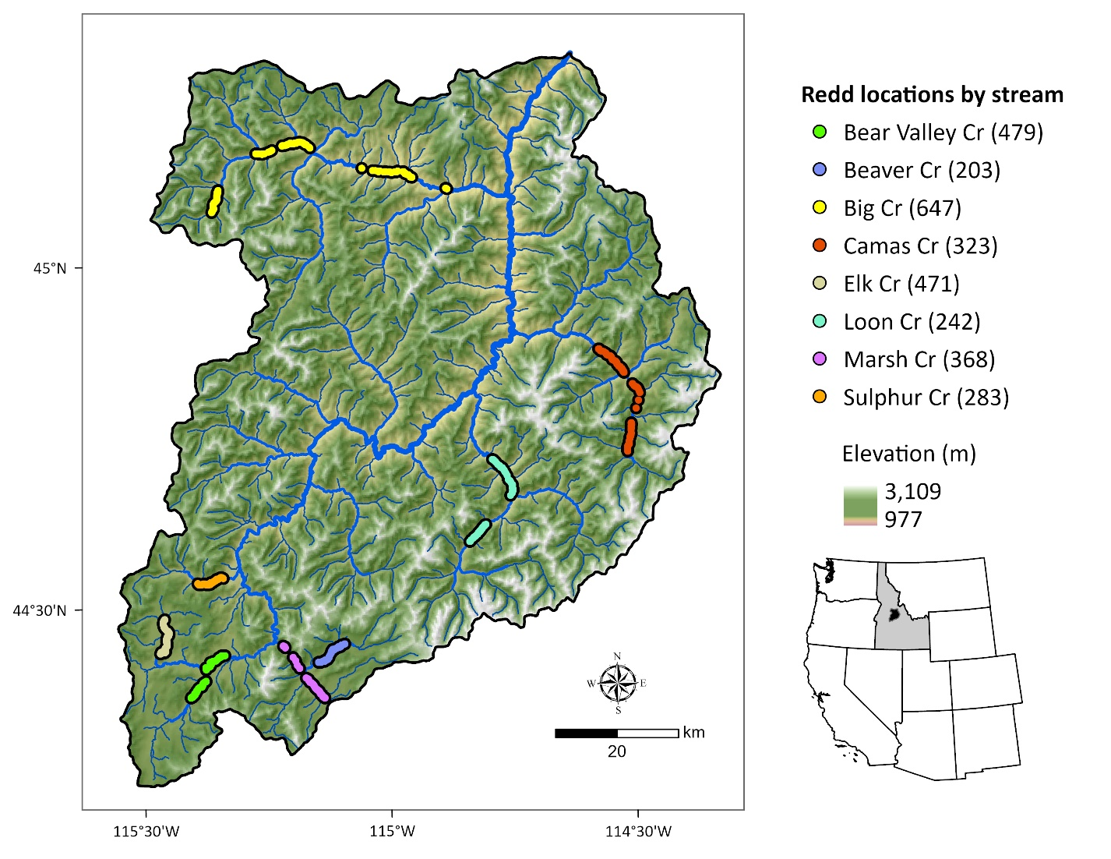Figure 1. Middle Fork Salmon River watershed illustrating major tributaries and locations of georeferenced Chinook Salmon redds from 2002 to 2005 (count of redds per stream given in parentheses). Point locations were dissolved for visualization.

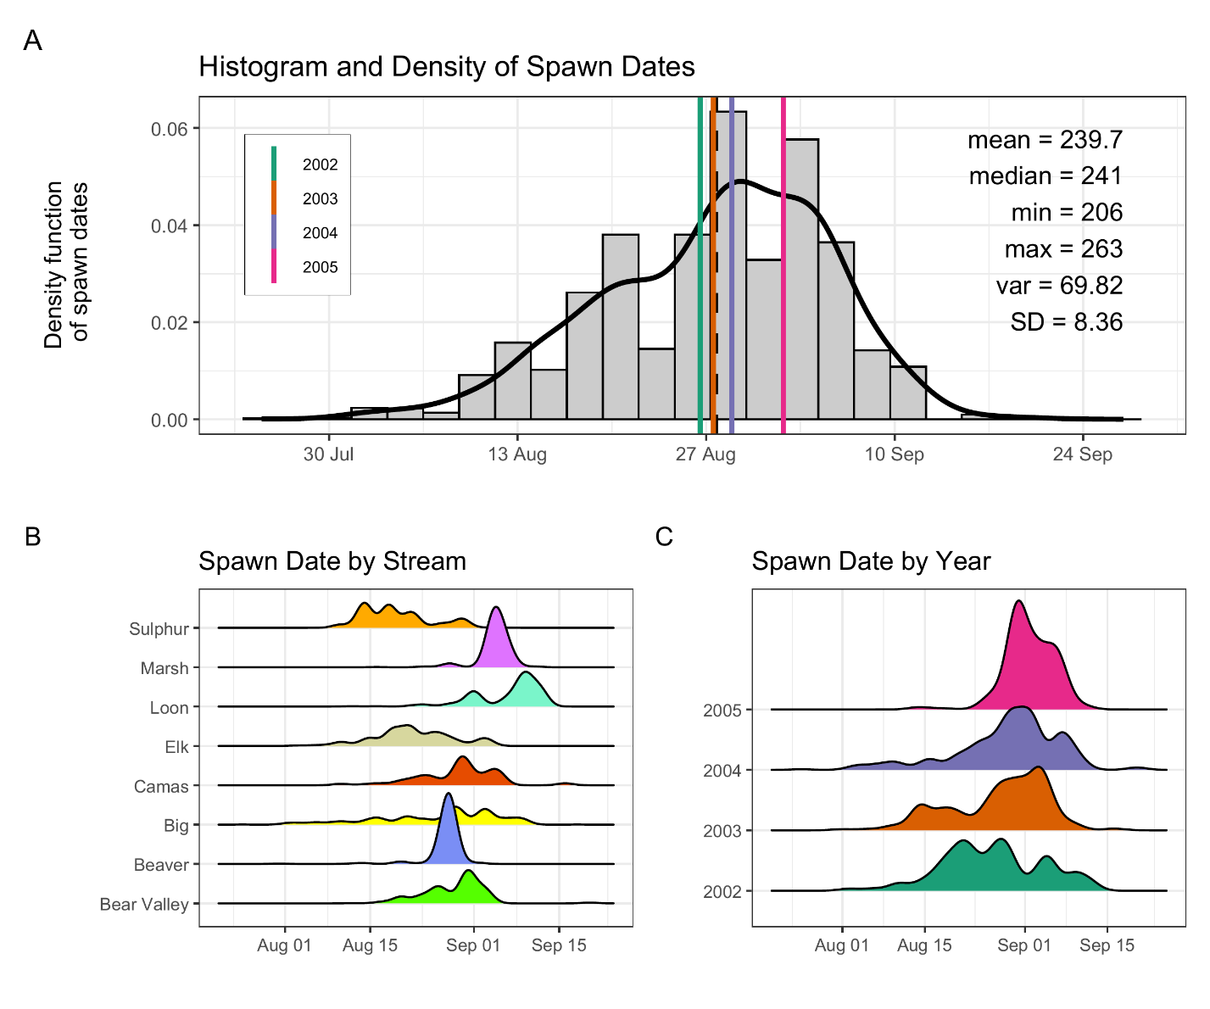
Figure 2: Histogram and density of Chinook salmon spawn timing across all streams and years (A), by stream (B), and by year (C). In panel (A), the histogram and kernel density illustrate the overall distribution of spawn dates; vertical-colored lines illustrate year-specific means, and the black line depicts the global mean. Spawn timing was generally unimodal, peaking in late August to early September.

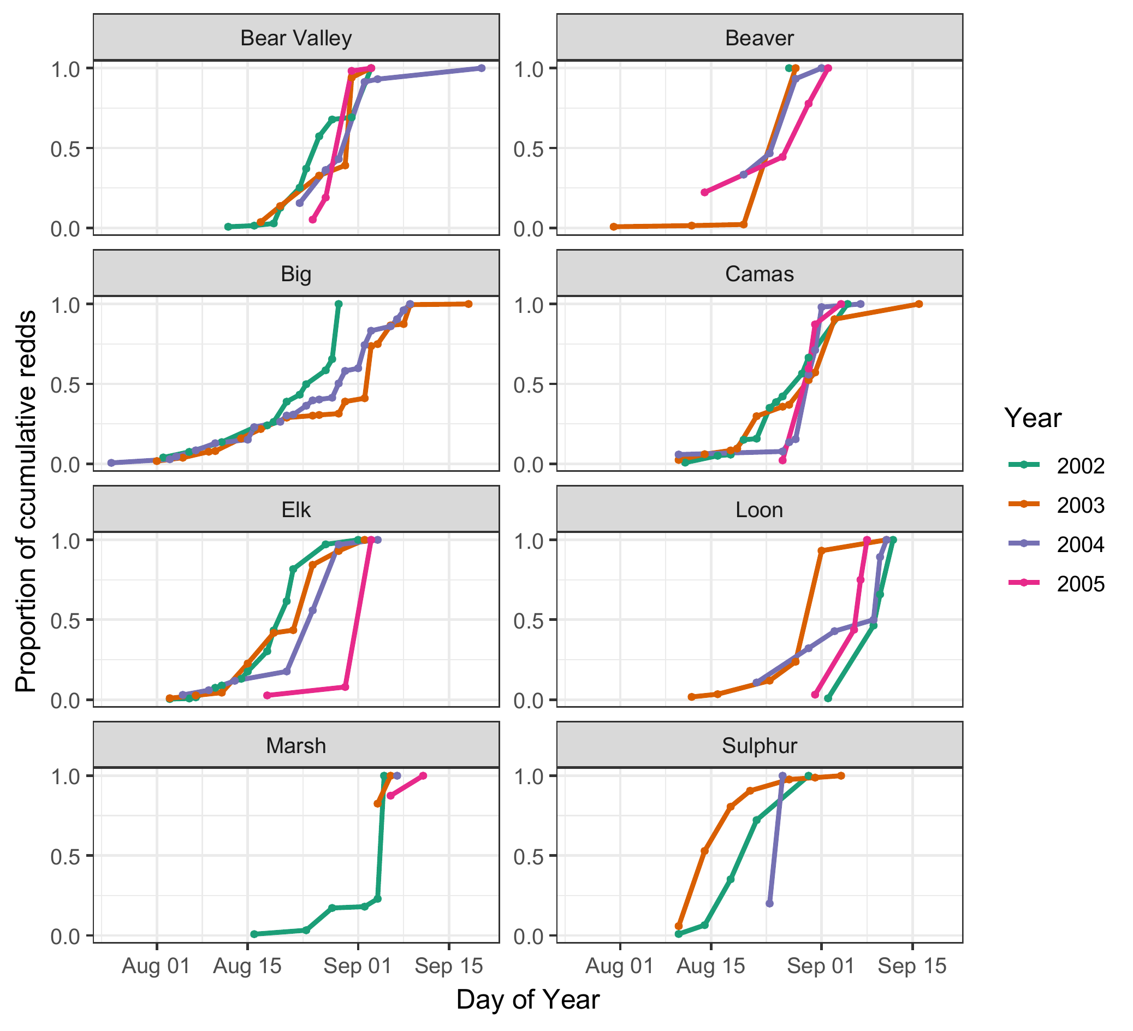
Figure 3. Proportion of cumulative Chinook salmon redds over time (day of year) across years (2002–2005) and streams. Each line represents a different year, denoted by color. Stream-specific panels illustrate temporal variation in the progression of spawning activity, as measured by cumulative redd counts normalized to the maximum value in each stream-year combination. From 2003-2005, only 2, 1, and 2 redd surveys, respectively, were completed in Marsh Creek.

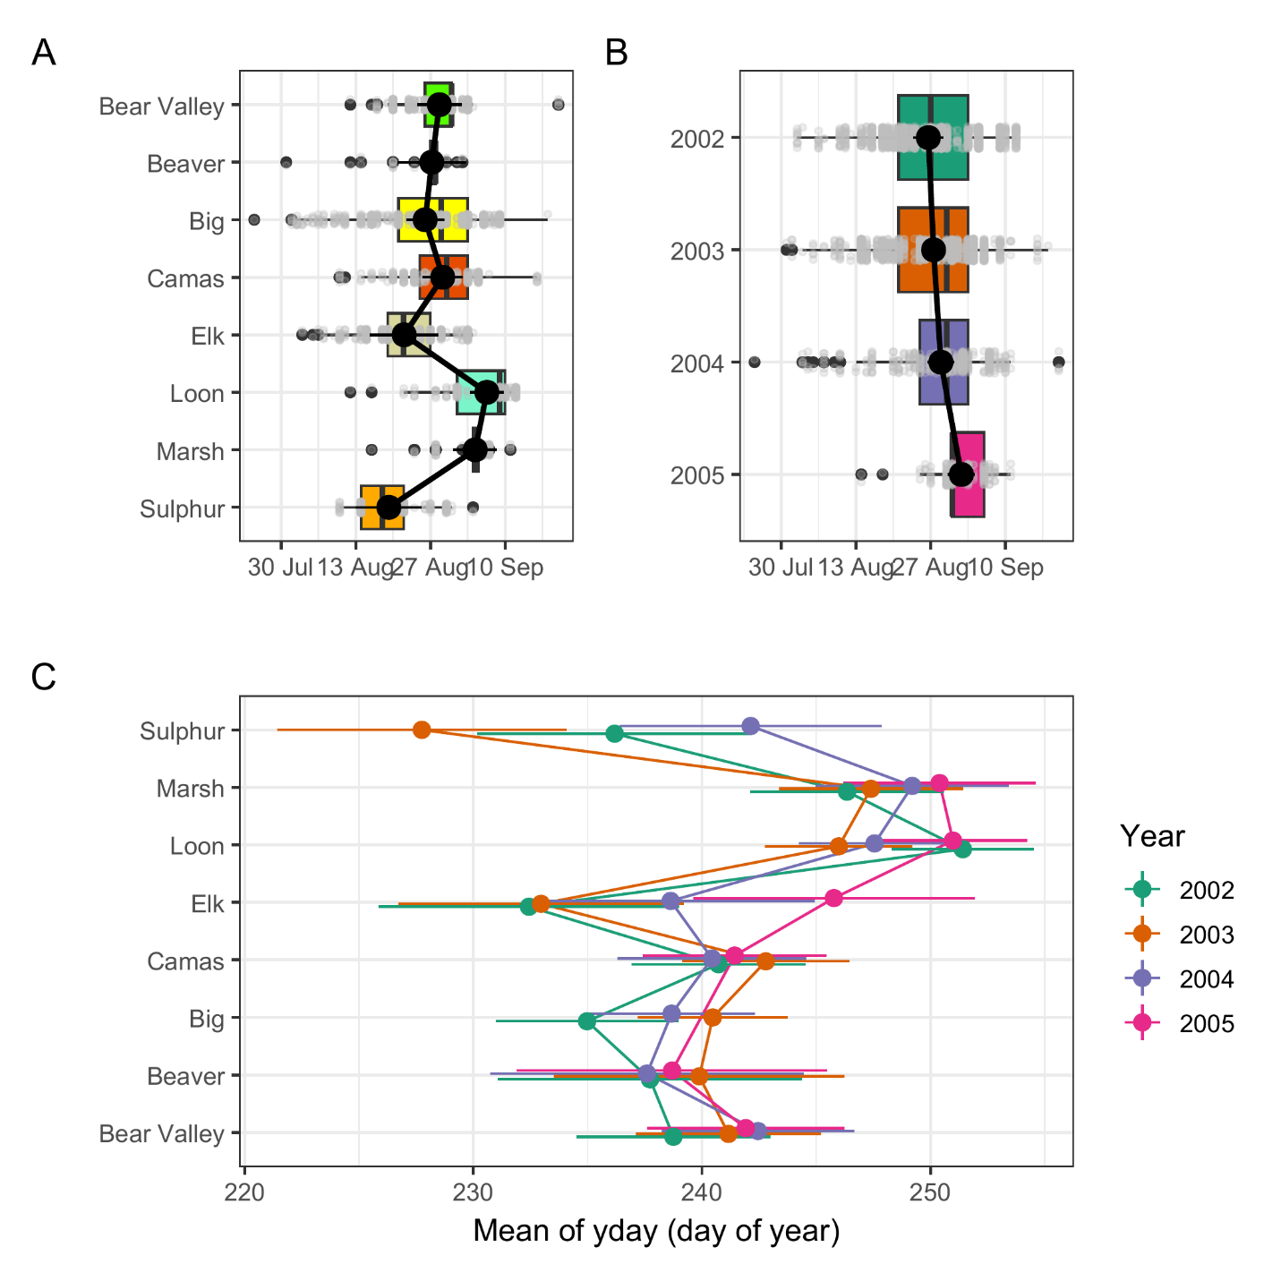
Figure 4. Predicted mean spawn dates by stream (A), year (B) and stream and year (C), from the final mixed-effects model. Black points with black lines (A, B), and colored points with horizontal lines (C) represent estimated marginal means and 95% confidence intervals. Boxplots in panels A and B illustrate the distribution of observed redd counts by group, with individual data points in grey. The modeled predictions represent marginal means accounting for fixed effects and averaged over random effects.
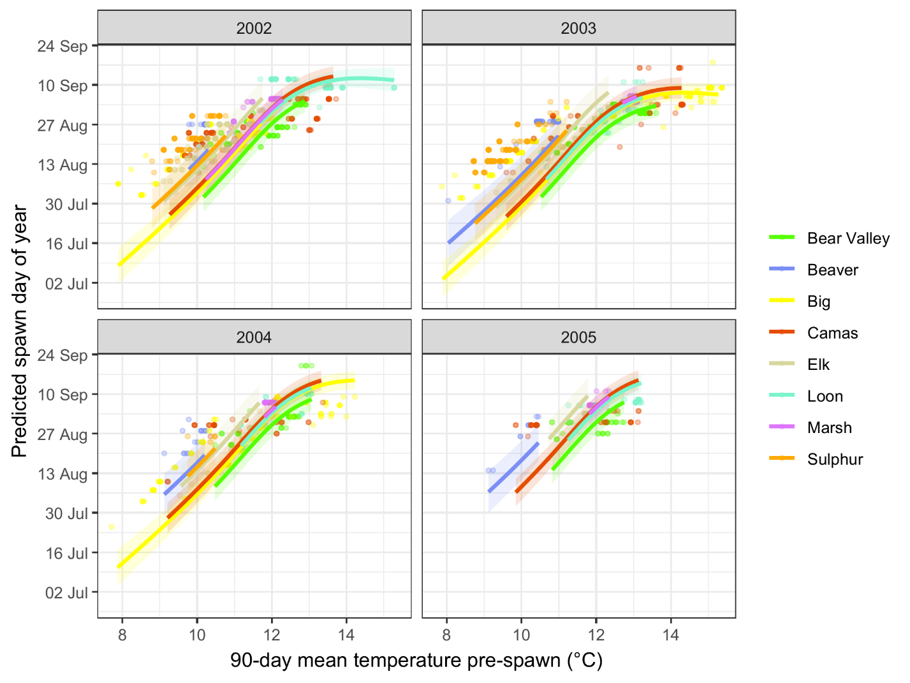
Figure 5. Predicted relationship between spawn timing and 90-day pre-spawn mean temperature by stream and year. Lines represent model predictions from the final mixed-effects model. Colored points illustrate observed spawn timing, shaded ribbons represent 95% confidence intervals for predictions.

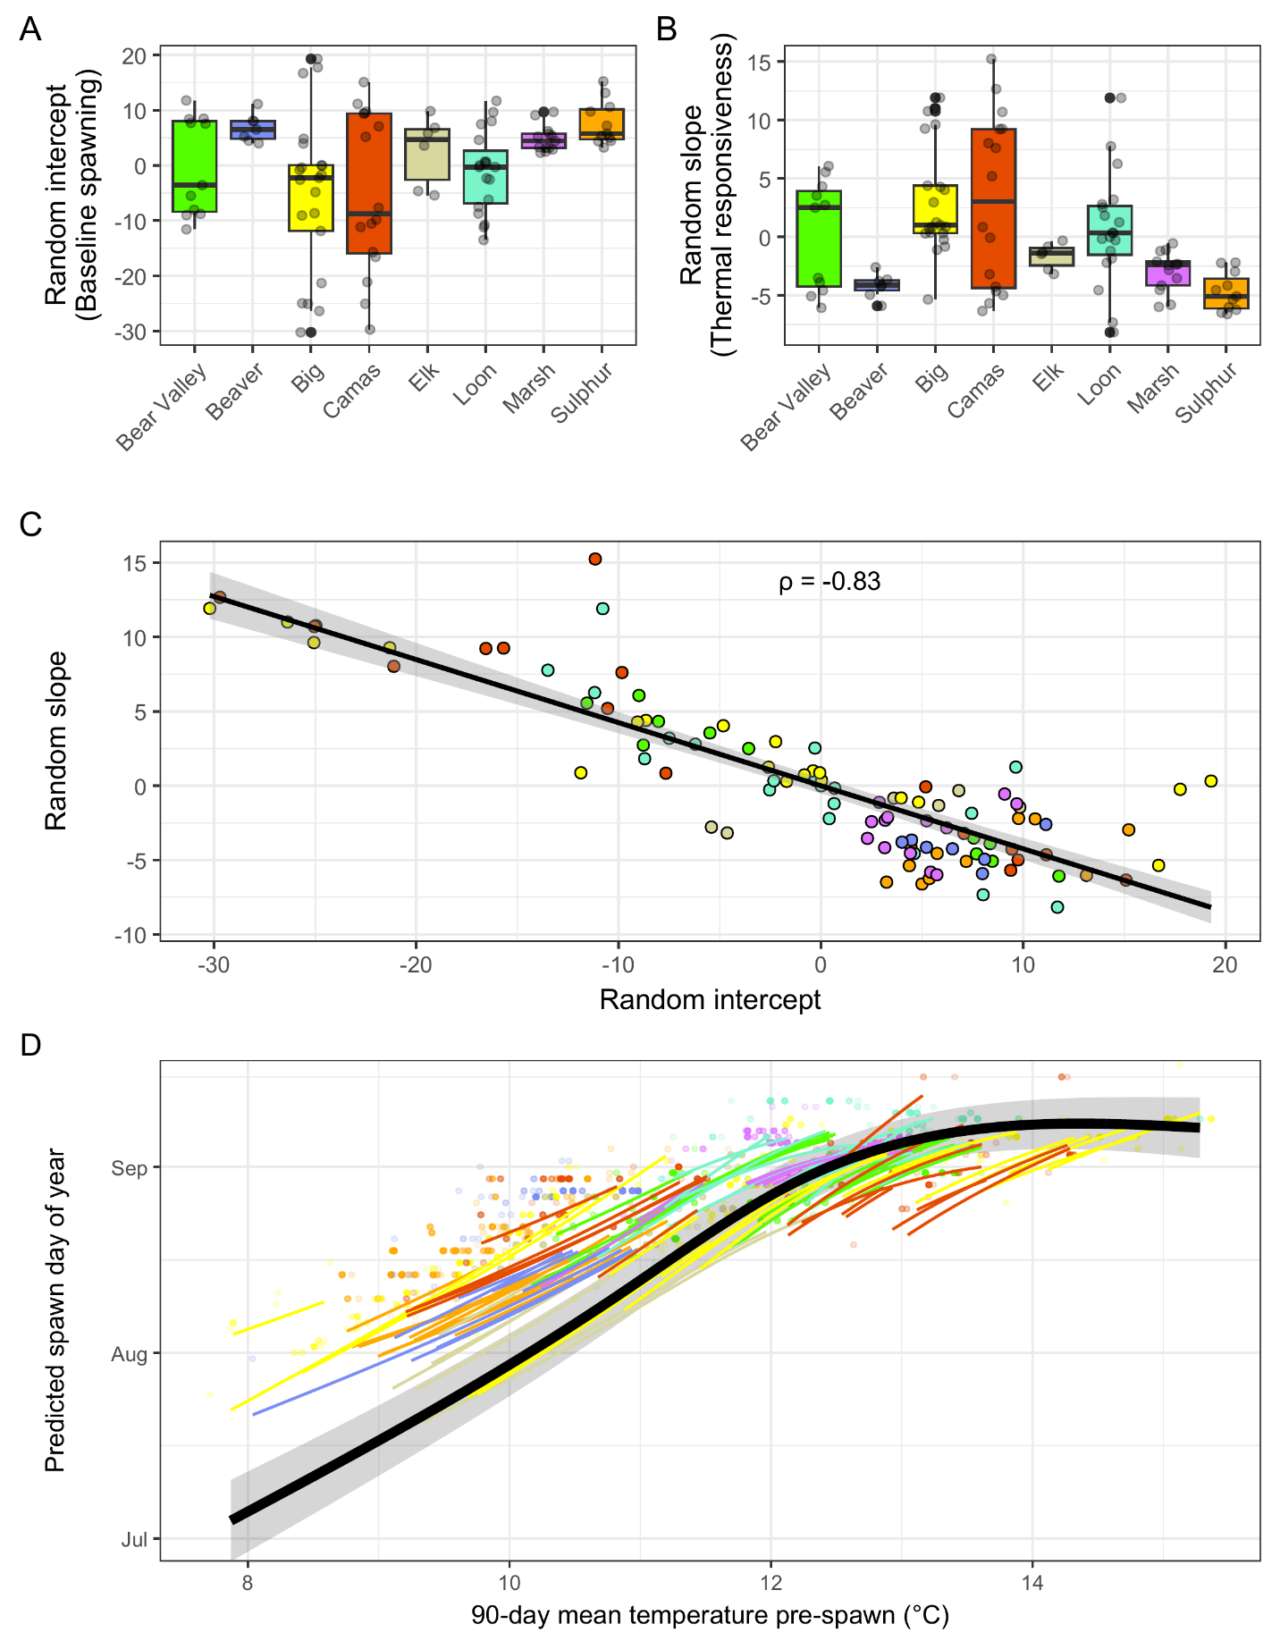
Figure 6: Reach-level (COMID) variation in random intercepts, random slopes, and predicted spawn timing relationships from the final mixed-effects model. (A) Boxplots of random intercepts by stream, representing reach-level deviations in baseline spawn timing after accounting for fixed effects (temperature, stream identity, and year); positive values indicate later-than-expected spawning, negative values indicate earlier-than-expected spawning. (B) Boxplots of random slopes by stream, representing reach-level deviations in thermal sensitivity (responsiveness of spawn timing to 90-day antecedent temperature); larger positive values indicate stronger temperature dependence. Points in A and B represent individual stream reaches (COMIDs). (C) Correlation between random intercepts and random slopes across all COMIDs, colored by stream. The strong negative relationship (ρ = −0.83) indicates that reaches with earlier baseline spawn timing exhibit greater thermal sensitivity. The line represents a linear fit with 95% confidence interval. (D) Predicted temperature–spawn timing relationships for individual COMIDs (colored lines, colored by stream) and the population mean response (black line with 95% confidence interval).

